**Lab Assignment No. 1**

#Sigmoid Function

import pandas as pd  
import numpy as np  
import seaborn as sns  
import matplotlib.pyplot as plt

def sigmoid_function(x):  
 return 1/(1+np.exp(-x))

x = np.linspace(-10, 10)

sns.scatterplot(x)  
plt.title("X data")

Text(0.5, 1.0, 'X data')

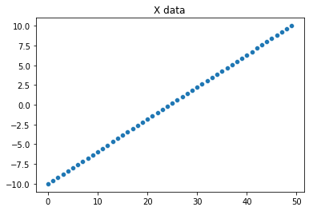

y = sigmoid_function(x)

sns.scatterplot(y)  
plt.title("Sigmoid Function")

Text(0.5, 1.0, 'Sigmoid Function')

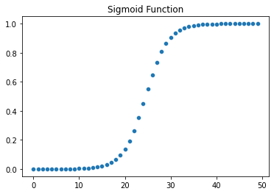

plt.plot(y)  
plt.title("Sigmoid Function")

Text(0.5, 1.0, 'Sigmoid Function')

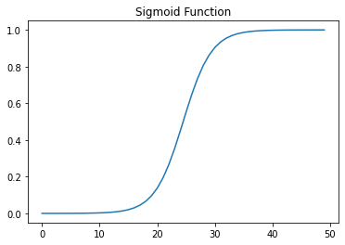

#Binary function

def binary_function(x):  
 return 0 if x<0 else 1

binary_output = []  
for i in [-10, -8, -5, -2, 0, 1, 2, 3, 8, 10]:  
 binary_output.append(binary_function(i))

binary_output

[0, 0, 0, 0, 1, 1, 1, 1, 1, 1]

sns.scatterplot(binary_output)  
plt.title("Binary Function scatterplot")

Text(0.5, 1.0, 'Binary Function scatterplot')

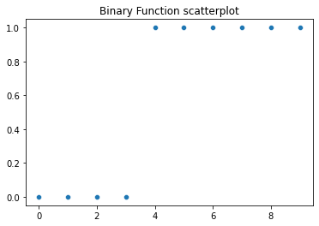

plt.plot(binary_output)  
plt.title("Binary function line plot")

Text(0.5, 1.0, 'Binary function line plot')

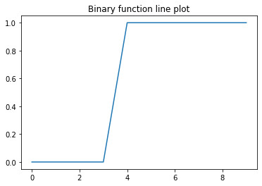

#Linear Function

def linear_function(a, x):  
 return a*x;

x = np.linspace(-10, 10)

y1 = [linear_function(1, i) for i in x]

y2 = [linear_function(2, i) for i in x]

y3 = [linear_function(3, i) for i in x]

plt.plot(y1)  
plt.plot(y2)  
plt.plot(y3)  
plt.title("Linear Function Graph")

Text(0.5, 1.0, 'Linear Function Graph')

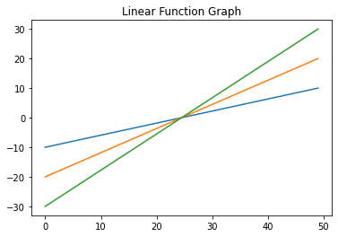

#Tanh

def tanh_function(x):  
 return (np.exp(x) - np.exp(-x) / np.exp(x) + np.exp(-x))

def tanh_function2(x):  
 return 2*sigmoid_function(2*x)-1

x = np.linspace(-50, 50, 5000)

y = [tanh_function(i) for i in x]

y_tanh = [tanh_function2(i) for i in x]

sns.scatterplot(y_tanh)

<Axes: >

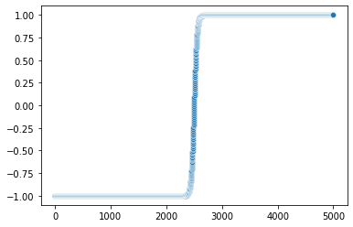

plt.plot(y_tanh)

[<matplotlib.lines.Line2D at 0x7f9a52d413a0>]

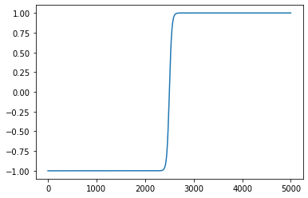

sns.scatterplot(y)

<Axes: >

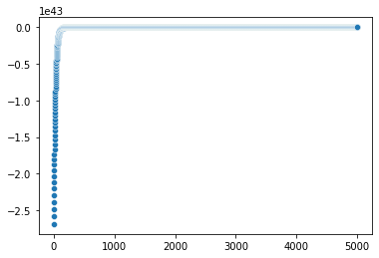

plt.plot(y)

[<matplotlib.lines.Line2D at 0x7f9a52c26790>]

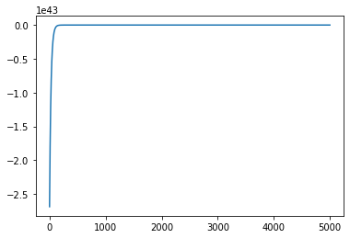

#Relu

def relu_function(x):  
 return np.array([0, x]).max()

x = np.linspace(-10, 10)

y = [relu_function(i) for i in x]

sns.scatterplot(y)  
plt.title("Relu Function")

Text(0.5, 1.0, 'Relu Function')

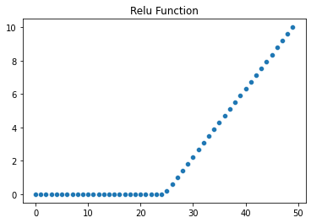

plt.plot(y)  
plt.title("Relu Function")

Text(0.5, 1.0, 'Relu Function')

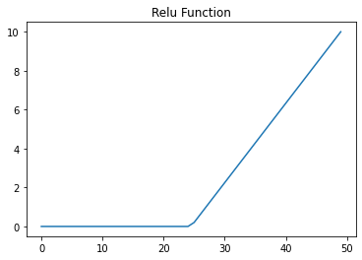

#leaky Relu

def leaky_relu_function(x):  
 return 0.01*x if x < 0 else x

x = np.linspace(-10, 10)

y = [leaky_relu_function(i) for i in x]

sns.scatterplot(y)  
plt.title('Leaky Relu Function')

Text(0.5, 1.0, 'Leaky Relu Function')

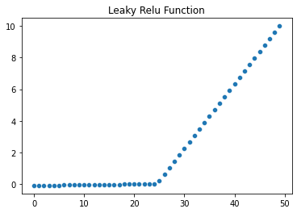

plt.plot(y)  
plt.title("Leaky Relu Function")

Text(0.5, 1.0, 'Leaky Relu Function')

